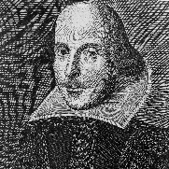
Ponderosa High School
English 4 – Shakespeare
Course Description: The World of Shakespeare is a fourth year course that centers on the in-depth study of William Shakespeare’s plays and poetry beyond the core literature assigned in the 9th and 10th grade English classes. You will be challenged to extend your critical thinking skills through reading, discussing, analyzing, performing, and writing about Shakespeare’s plays and poems. These skills will be demonstrated through intensive essay writing, projects, and presentations. Class format will be interactive, with an emphasis on active participation. Reading skills will be sharpened, vocabulary expanded, and writing skills refined.
Our major units this year will be:
Introduction to William Shakespeare and Sonnets
The Taming of the Shrew
Othello
Henry IV, Part 1 and parts of Henry V
Macbeth
Twelfth Night
Hamlet
The Tempest

